Interaction Laws for Dependability Explicit Computing in Open Multi-agent Systems

Rodrigo Paes, Gustavo Carvalho, Carlos Lucena
LES, PUC-Rio
Rua Marquês de São Vicente 225, Rio de Janeiro/RJ, Brazil, 22453-900
[rbp, guga, lucena]@inf.puc-rio.br

Ricardo Choren
SE/8, IME
Praça General Tibúrcio 80, Rio de Janeiro/RJ, Brazil, 22290-270
choren@ime.eb.br

Abstract: In an open multi-agent system (MAS), agent autonomy and heterogeneity may possibly exploit cooperation, leading the system to an undesirable state. Since a MAS has no central control, a coordination mechanism must be developed to allow agents to fulfill their design goals. In this paper we propose to incorporate the Dependability Explicit Computing (DepEx) ideas into a law-governed approach in order to build dependable open MAS. We show that the law specification can explicitly incorporate dependability concerns, collect data and publish them in a metadata registry. This data can be used to realize DepEx and, for example, it can help to guide design and runtime decisions. The advantages of using a law-approach are (i) the explicit specification of the dependability concerns; (ii) the automatic collection of the dependability metadata reusing the mediators’ infrastructure presenting in law-governed approaches; and (iii) the ability to specify reactions to undesirable situations, thus preventing service failures.
I. INTRODUCTION
Many current systems are open and dynamic. A key characteristic is that they demand dynamic binding, i.e. the selection and use of components at runtime. Autonomous agents and multi-agent systems (MAS) represent a new way of analyzing, designing, and implementing open, dynamic software systems [6]. An open MAS does not simply consist of agents selected during a design activity. Instead, they are open to agents that may arrive, depart or be modified. They are dynamic in to provide services on a continuous basis, and do so even when agents or the environment change [13].
The greater the dependence of our society on such open MAS, the greater will be the demand for dependable applications. The dependability of a computing system can be defined as the ability of a system to avoid failures that are more frequent or more severe, and outage durations that are longer, than is acceptable. [1]. Dependability is an integrating concept that encompasses the following attributes [1]: (i) availability: readiness for correct service; (ii) reliability: continuity of correct service; (iii) safety: absence of catastrophic consequences on the user(s) and the environment; (iv) integrity: absence of improper system alterations; and (v) maintainability: ability to undergo modifications and repairs.
One way to promote dependability is by implementing a Dependability Explicit Computing (DepEx) approach [8]. DepEx main idea is to incorporate effective concern for the achievement of any necessary dependability targets into the full system life cycle. Thus design and implementation files are annotated with dependability-related metadata, which are updated when the files are processed (e.g. when development moves from one phase to another). Then at the runtime, the dependability metadata can be exploited to aid decision-making. Examples of metadata are safety integrity level, failure rates, pre and post conditions, MTBF, response time, resources consumed, etc.
Achieving dependability in open MAS is particularly challenging. Such systems have little or no control over the actions the agents can perform and the internal aspects of the agents (e.g. implementation language and architecture) are inaccessible. Interaction laws deal with this problem by explicitly specifying behavioral rules, and by providing mechanisms that check if the actual interactions conform to the specification at runtime. The mechanisms are usually implemented by either a central mediator or by a decentralized community of mediators [9]. These mediators perform the active role of monitoring the interaction among the agents and interpreting the laws to verify if the actual system behavior is in conformance with the specifications.
This paper proposes to incorporate the DepEx ideas into a law-governed approach in order to build dependable open MAS. Law specification can explicitly incorporate dependability concerns, collect data and publish them in a metadata registry. The advantages of using a law-approach are (i) the explicit specification of the dependability concerns; (ii) the automatic collection of the dependability metadata reusing the mediators’ infrastructure presenting in law-governed approaches; and (iii) the ability to specify reactions to undesirable situations, therefore, preventing service failures.
This paper is organized as follows. Section 2 presents a flexible law-governed approach called XMLaw. This approach is used throughout the examples given in this paper. Section 3 presents a case study to discuss how the laws can be used to promote DepEx. Section 4 shows some related work on promoting dependability in open MAS. Finally, Section 5 presents some conclusion about this work.

II. XMLAW
XMLaw [10] is used to represent the interaction laws of an open system specification. Laws in XMLaw were originally written in an XML-based language. XMLaw follows an event-driven approach, i.e., law elements communicate by the exchange of events.
The XMLaw conceptual model is composed of the following main elements: event, protocol, transition, state, scene, clock, norm, constraint, action. An event models an occurrence related to the elements of the law. It can represent a change of state of a protocol, the arrival of a message sent by an agent, the moment in which an agent acquires an obligation, an announcement that a certain amount of time has elapsed and much more. The semantic of each event is determined by its type. There are many types of events, e.g. message_arrival, compliant_message, transition_activation, failure_scene_completion, sucessful_scene_completion, scene_creation, clock_activation, clock_tick, clock_timeout, clock_deactivation, norm_activation, norm_deactivation.
A protocol defines the possible states that an agent interaction can evolve. Transitions between states can be fired by any XMLaw event, instead of only message arrivals. Therefore, protocols specify the expected sequence of events in the path of interaction among the agents. A transition is a directed arc between a source state and an end state. It represents the change between two different situations in the course of the interactions caused by a response to the occurrence of an XMLaw event. Transitions may depend on norms and constraints to fire. If there is an obligation associated with the transition, then the obligation must be inactive in order to activate the transition. Instead, if there is a permission associated with the transition, the permission must be active in order to fire the transition. Constraints may act as fine-grained filters for transitions. A constraint could access a database, do some math, calculate date periods or perform any other complex domain-dependent operation in order to allow the transition to fire.
A state models a possible step in the evolution of the agents’ interaction. States can represent static or dynamic situations and there are three types of states: successful, failure or execution. A successful state means that the protocol stops upon reaching success. A failure state means that the protocol stops with failure when the state is reached. An execution state does not stop the protocol. Scenes help organize interactions. The concept of scenes here is similar to those in theater plays, where actors play a role according to well defined scripts, and the entire play is composed of many connected scenes. A scene models an interaction context where protocols, actions, clocks and norms can be composed to represent complex normative situations. Furthermore, from the problem modeling point of view, a scene allows for the decomposition of the problem into smaller and more manageable pieces of information. They can be viewed as building blocks of normative interactions. Normative interactions are situations in which agents interact through a set of behavioral rules, or social conventions. Clocks represent time restrictions or controls and can be used to activate other law elements. Clocks indicate that a certain period has elapsed producing clock_tick events. Once activated, a clock can generate clock_tick events. Clocks are activated and deactivated by law elements.
A norm is an element used to enable or disable agents’ conversation paths. For instance, a norm can forbid an agent to interact in a negotiation scene. There are three types of norms with different semantics in XMLaw: obligations, permissions and prohibitions. The obligation norm defines a commitment that software agents acquire while interacting with other entities. For instance, the winner of an auction is obligated to pay the committed value and this commitment might contain some penalties to avoid breaking this rule. The permission norm defines the rights of a software agent at a given moment, e.g. the winner of an auction has permission to interact with a bank provider through a payment protocol. Finally, the prohibition norm defines forbidden actions of a software agent at a given moment; for instance, if an agent does not pay its debts, it will not be allowed future participation in a scene.
The structure of the permission (Table 1), obligation and prohibition elements are equal. Each type of norm contains activation and deactivation conditions. In Table 1, an assembler will receive the permission upon logging into the scene (scene activation event called negotiation) and will lose the permission after issuing an order (event orderTransition). Furthermore, norms define the agent role that owns it through the second parameter. In Table 1, the assembler agent ($assembler) will receive the permission. Norms can also have constraints and actions associated with them. Norms also generate activation and deactivation events. For instance, as a consequence of the relationship between norms and transitions, it is possible to specify which norms must be made active or deactivated for firing a transition. In this sense, a transition only could fire if the sender agent has a specific norm.
A constraint is a restriction to norms or transitions and, generally, it specifies filters for events, constraining the allowed values for a specific attribute of an event. For instance, messages carry information that is enforced in various ways. A message pattern enforces the message structure fields. A message pattern does not describe what the allowed values for specific attributes are, but constraints can be used for this purpose. Thus developers are free to build as complex constraints as needed for their applications. Constraints are defined inside Scene (Table 2) or Norm (Table 1) elements. Constraints are implemented using Java code. The Constraint element defines the class attribute that indicates the Java class that implements the filter. This class is called when a transition or a norm is supposed to fire, and basically the constraint analyzes if the message values or any other events' attributes are valid. Table 2 shows a constraint that verifies if the date expressed in a message is valid; if it is not, the message will be blocked. In Table 1, a constraint is used to verify the number of messages that the agent has sent until now; if it has been exceeded, the permission is no longer valid.
Table 1: XMLaw specification of the permission structure
// norm definition
01: assemblerPermissionRFQ{permission, $assembler, (negotiation), (orderTransition)
// constraint declared in the context of the norm
02: checkCounter{br.pucrio.CounterLimit}
// actions declared in the context of the norm
03: permissionRenew{(nextDay), br.pucrio.ZeroCounter}
04: rfqTransition{(rfqTransition), br.pucrio.RFQCounter}
05: } //end norm definition

Table 2: Constraint checkDueDate used by a transition
01: negotiation{
...
09: t1{s1->s2, rfqMsg, [checkDueDate]}
...
14: checkDueDate{br.pucrio.ValidDate}
...
20:} // end scene

An action supports the definition of the moment when the mediator should call a domain-specific service. Actions are domain-specific Java code that runs in an integrated manner with XMLaw specifications. Actions can be used to plug services into a governance mechanism. For instance, a mechanism can call a debit service from a bank agent to charge the purchase of an item automatically during a negotiation. In this case, we specify in the XMLaw that there is a class that is able to perform the debit. Of course, this notion could also be extended to support other technologies instead of Java, such as direct invocation of web-services. In XMLaw, an action can be defined in three different scopes: Law, Scene and Norms. Since actions are also XMLaw elements, they can be activated by any event such as transition activation, norm activation and even action activation. The action structure is shown in the example of Table 1 at lines 03 and 04 (in this example: a norm action). The class attribute of an Action specifies the Java class in charge of the functionality implementation. The first parameter references the events that activate this action, and as many events as needed can be defined to trigger an action.
The flexibility achieved by using the event-driven approach at a high-level of abstraction is not present in the other high level law approaches [3, 5]. The advantages claimed in favor of the use of events as a modeling element are also present in LGI [9], however at a low level of abstraction. A flexible underlying event-based model as presented in XMLaw can allow conceptual models for governance to be more prepared to accommodate changes. This is specially needed when we consider using the law-approach to deal with new concerns not considered in its original specification, such as dependability.
II. 1 M-Law
XMLaw laws are interpreted by the M-Law mediator [12] that, at runtime, analyzes the compliance of agents with interaction law specifications. M-Law is a middleware that provides a communication component, or mediator, for enforcing interaction laws. M-Law was designed to allow extensibility in order to fulfill open system requirements or interoperability concerns. A law specification is a description of law elements that are interrelated in a way that makes it possible to specify interaction protocols using time restrictions, norms, or even time sensitive norms.
The M-Law mediates the communication between the agents. The behavior of the M-Law is specified in the XMLaw file that it reads. In fact, M-Law works by intercepting messages exchanged between agents, verifying the compliance of the messages with the laws and subsequently redirecting the message to the real addressee, if the laws allow it. If the message is not compliant, then the mediator blocks the message and applies the consequences specified in the law (Figure 1). A more detailed explanation about how M-Law was implemented can be found in [11].
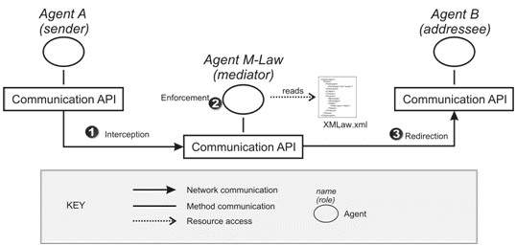
Figure 1: M-Law architecture
III. IMPLEMENTING DEPEX USING XMLAW
DepEx intends to incorporate effective concern for the achievement of any necessary dependability targets into the full system life cycle. This involves identifying explicit dependability requirements and exploiting this information throughout the development process, and during system deployment, in order to provide dependability-related guidance to all decisions. The notion is to annotate all design information files (e.g. specifications, code, etc.) with dependability-related meta-information, and to use and update this meta-information as the files themselves are processed [7].
XMLaw is used to specify the laws in such a way that the dependability metadata is treated as first-class data. Currently, the metadata information present in law definitions using XMLaw includes metadata concerning availability, service failure and enforcement of pre and post conditions.
(i) Availability: every time an agent sends a request to other agent, the receiver should answer within a pre-specified amount of time. The absence of an answer implicates that at that time the receiver is not available with the required quality level.
(ii) Service failure: during the interaction, agents acquire obligations that they must fulfill. The fulfillment of these obligations represents the expected correct behavior for the agents. Therefore, each obligation that is not fulfilled can be interpreted as a service failure, i.e., the actual system execution deviates from the correct behavior.
(iii) Pre and post conditions: agent specifications may likely change as agents evolve, but resilience may be maintained if it is possible to reason dynamically about the functional properties of agents, including abnormal behaviors. Dynamic resilience mechanisms require agent specifications as metadata, including both specifications of services offered and services required. These can be given by pre-/post-conditions, potential failure behaviors and responses when the components are used outside their pre-conditions.
Such meta-information is likely to be composite in open MAS, and it should be processed using meta-level operations associated with tools that will carry forward the dependability process. The M-Law middleware is used to process dependability metadata specified with XMLaw. The main idea is that XMLaw will be used to describe dependability information during system development thus providing a trace of the dependability-related decisions and actions taken during design. Then M-Law will execute meta-level operations, providing traceable evidence regarding the dependability of the system.
III.1. DepEx Architecture using XMLaw and M-Law
To allow the development and implementation of DepEx concepts using XMLaw and the M-Law middleware a metadata architectural model was conceived for the achievement of predictable levels of dynamic resilience in distributed systems (Figure 2). The architecture is based on the model presented in [13]. This model was chosen because it already contains the components to enable DepExp. It has a metadata registry, a runtime reasoning/adaptation service and a metadata acquisition component.
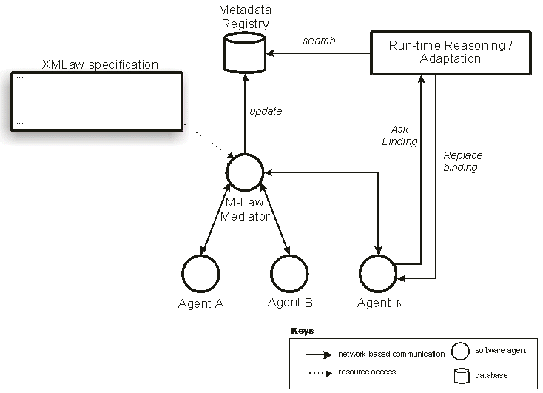
Figure 2: The XMLaw and M-Law Architecture for DepEx
The architecture is composed of five components: the M-Law mediator, the XMLaw specification, the metadata registry, the runtime reasoning and the application agents. As stated before, the M-Law mediator intercepts messages exchanged between agents and verifies the compliance of these messages with the laws. The architecture is based on a pool of mediators that intercept messages and interpret the previously described laws. As more clients are added to the system, additional mediators’ instances can be added to improve throughput.
In the XMLaw specification there are instructions that tell the mediator how to update the metadata registry. At runtime, the metadata registry can be used in two ways: directly by the agents or through the runtime reasoning. The agents can proactively search for metadata and self-adapt to reflect their dependability requirements. As an example, a user agent can search for a travel agent that has not broken any obligation during the last month.
The runtime reasoning provides different tasks related to the processing of metadata stored in the metadata registry, such as comparison/matching of metadata, determination of equivalent metadata information and composition of metadata [13]. This service manages the list of agents, seamlessly activating or connecting the ones that will be used according to a specified resilience policy program.
IV. A SAMPLE SCENARIO
This section presents a motivating case study to illustrate how to specify the laws in such a way that the dependability metadata is treated as first-class data. The problem description was already reported in [14], and it was slightly modified to this case study.
Consider the task of creating a system composed of three types of agents: a travel agent, a user agent and an airline agent. The airline provides several related operations, which must be invoked according to a complex conversation protocol. Assume that the airline agent provides five different operations: checkSeatAvailability, reserveSeats, cancelReservation, booikSeats, and notifiyExpiration. Each operation performs a single airline travel related task. The operations must be invoked by a client according to the following conversation rules:
- checkSeatsAvailability must be the first operation to be invoked;
- reserveSeats may only be invoked if a client has already invoked checkSeatsAvailability and the requested seats are indeed available; the reservation is held only for a certain amount of time;
- bookSeats or cancelReservation may be invoked, but only if the seats have been reserved (by a successful invocation of reserveSeats) and the reservation has not expired;
- if neither bookSeats nor cancelReservation has been invoked by the client within a specified amount of time, the airline agent will itself invoke notifyExpiration to inform the client that the reservation has expired.
A user agent, planning on taking a trip submits a TripOrder to its travel agent, hoping to get an Itinerary proposal. The TripOrder is sent through the getItinerary message and contains information such as departure and destination, departure date and time, and return date and time (for a round trip), the number of maximum connections and the number of travelers. The travel agents finds the best itinerary to reach the destination based on the traveler’s criteria such as the cheapest fare, availability of flights, or frequent flyer miles accumulated by the traveler. Before the Itinerary can be proposed to the traveler, the travel agent invokes the airline agent to verify the availability of seats (checkSeatsAvailability). In the event the seats are available, the travel agent notifies the traveler and waits for the traveler to submit a modified TripOrder.
If seats are available, the proposed Itinerary is sent to the traveler for confirmation. It then decides to reserve the seats for the Itinerary and gives the travel agent its contact information so that the airline agent can send it an e-ticket. Next, the travel agent interacts with the airline agent to finalize the reservation (reserveSeats). Assume that the airline holds such reservation for one day, and that if a BookRequest is not received within one day, the seats are released and the travel agent is notified. The travel agent sends a ReserveResult message to the traveler as an acknowledgment.
At this point, the traveler can either book or cancel the reservation. If it decides to book the trip, it sends a BookRequest to the travel agent containing its credit card information. The travel agent then invokes the bookSeats operation of the airline agent to finally book the seats. As a result, the airline agent books the seats for the proposed Itinerary, and issues an e-ticket to the traveler.
IV.1. Some Sample Scenario Requirements
This section will illustrate six requirements for the sample scenario, described above, which can be explicitly related to dependability issues.
- The whole process must occur within two days. After two days, the process is cancelled and all the rules are no longer valid. All the interactions must restart.
- All interactions must take place as the pre-defined order specified in the problem description (Section IV).
- If the airline agent says there is a seat available, this seat must be saved to the travel agent for at least five minutes. This way, the user has some time to decide whether to confirm the reservation. If the time has elapsed, and the airline has not received any confirmation, then the airline is allowed to answer with a not-available message and book the seat for another client.
- When the airline agent sends a result-ok message in response to a seat reservation, then the reservation must be held for at least one day
- The TripOrder (getItinerary message) must belong to the set of possible attributes S={“Toronto”, “New York”, “London”, “Tokyo”, “Rio de Janeiro”}.
- Every request that does not require user interaction must be answered within 15 seconds by any agent.
IV.2. Dependability Metadata Acquisition through XMLaw Specification
The sample scenario protocol can be described as a state machine (Figure 3). The complete XMLaw specification for this protocol is shown in Table 3. The scene is declared in lines 01 and 02. Lines 03 to 16 show the pattern of messages that agents are expected to exchange. Lines 17 to 20 specify the initial and final states of the interaction protocol. The transitions are specified in lines 21 to 37. The transitions refer to the states, messages, constraints and norms present in the law. Clocks are specified in lines 38 to 40, constraint in line 41, actions in lines 42 to 44, and norms in lines 45 and 46.

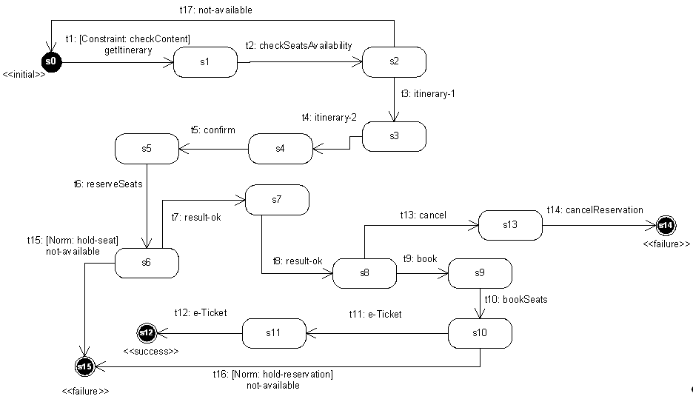
Figure 3: Sample scenario protocol specification
Table 3: Sample scenario XMLaw specification
// scene specification
01:planningATrip{
02: time-to-live=2d
// pattern of messages
03: getItinerary{userAgent,travelAgent,trip_order($dep, $dest, $depDate, $depTime, $retDate, $retTime, $maxCon, $travellers)}
04: checkSeatsAvailability{travelAgent,airlineAgent, $trip_order}
05: itinerary-1{airlineAgent, travelAgent, itinerary($id,$details)}
06: itinerary-2{travelAgent, userAgent, itinerary($id,$details)}
07: confirm{userAgent, travelAgent, confirm($id)}
08: reserveSeats{travelAgent, airlineAgent, reserveSeats($id)}
09: result-ok-1{airlineAgent, travelAgent, ok($id)}
10: result-ok-2{travelAgent, userAgent, ok($id)}
11: book{userAgent, travelAgent, book($id)}
12: bookSeats{travelAgent, airlineAgent, bookSeats($id)}
13: e-Ticket{$sender, $receiver, e-ticket($ticketId)}
14: cancel{userAgent, travelAgent, cancel($id)}
15: cancelReservation{travelAgent, airlineAgent, cancelReservation($id)}
16: not-available{airlineAgent, travelAgent, not-available($id)}

// initial and final states
17: s0{initial}
18: s12{success}
19: s14{failure}
20: s15{failure}

// transitions
21: t1{s0->s1, getItinerary, [checkContent]}
22: t2{s1->s2, checkSeatsAvailability}
23: t3{s2->s3, itinerary-1}
24: t4{s3->s4, itinerary-2}
25: t5{s4->s5, confirm}
26: t6{s5->s6, reserveSeats}
27: t7{s6->s7, result-ok-1}
28: t8{s7->s8, result-ok-2}
29: t9{s8->s9, book}
30: t10{s9->s10, bookSeats}
31: t11{s10->s11, e-Ticket}
32: t12{s11->s12, e-Ticket}
33: t13{s8->s13, cancel}
34: t14{s13->s14, cancelReservation}
35: t15{s6->s15, not-available, [hold-seat]}
36: t16{s10->s15, not-available, [hold-reservation]}
37: t17{s2->s0, not-available}

// Clocks
38: availability-clock{15s, regular, (t1,t2,t3,t5,t6,t7.t9,t10,t11,t13), (t2,t3,t4,t6,t7,t8,t10,t11,t12,t16,t17)}
39: hold-seat-clock{5m, regular, (t3), (t6)}
40: hold-reservation-clock{1d, regular, (t7), (t10)}

// Constraints
41: checkContent{br.pucrio.CheckContent}

// Actions
42: updateClockMetadata{(availability-clock), br.pucrio.DecAvailability}
43: updateHoldSeatMetadata{((hold-seat, norm_not_fulfilled)), br.pucrio.HoldSeat}
44: updateHoldReservationMetadata{((hold-reservation, norm_not_fulfilled)), br.pucrio.HoldReservation}
// Norms
45: hold-seat{obligation, airlineAgent, (t3), (hold-seat-clock, t7)}
46: hold-reservation{obligation, airlineAgent, (t7), (hold-reservation-clock , t11)}
47:}

The six requirements listed in section IV.1 can be specified as laws using XMLaw, as follows. Requirement 1 is implemented as the time-to-live scene attribute in line 02. The interaction protocol in Figure 3 reflects exactly the possible paths of interactions described for the sample scenario. This protocol is specified in lines 03 to 37. These lines declare all messages, states and transitions present in the protocol, describing requirement 2.
Requirement 3 demands a combined use of various XMLaw elements. First, it is necessary to identify when the airline agent “says there is a seat available”. Then, we have to start to count five minutes. The airline is not allowed to answer not-available within these five minutes. Table 4 shows the sequence of observed events that makes it possible to specify this requirement. This table is mapped to the XMLaw specifications in lines 35, 39, 43 and 45 in Table 3.
Requirement 4 is specified in XMLaw using an idea similar to requirement 3. The transition t16 (line 36) only fires if the obligation hold-reservation (line 46) is deactivated. The clock hold-reservation-clock (line 40) counts the time until one day. And the action updateHoldReservationMetadata updates the metadata registry with information about agents that do not fulfill the obligation.
Table 4: Rationale for the XMLaw specification of the req. 3 in lines 35, 39, 43 and 45
Airline agent sends itinerary-1 message to the travel agent. It means that airline agent is saying: “there is a seat available”. Then, we activate the clock to start counting the time. Moreover, we also activate the obligation hold-seat, and give it to the airline agent.
WHEN (t3, transition_activation)
ACTIVATE hold-seat-clock, hold-seat
If the time that the airline must hold the seat has elapsed (clock_tick event), then the obligation does not need to be fulfilled, i.e., the airline agent can answer with a not-available message.
WHEN (hold-seat-clock, clock_tick)
DEACTIVATE hold-seat
If the airline agent answers with a result-ok to a reserveSeats requisition, it means that the airline agent has fulfilled its obligation of holding the seat. Then, the obligation should be deactivated.
WHEN (t7, transition_activation)
DEACTIVATE hold-seat
The transition t15 only fires if the obligation hold-seat is deactivated. If the airline sends the not-available message while the obligation is still active, then a norm_not_fulfilled event will be generated and the transition will not fire. As we are concerned with acquiring metadata about agents that do not follow the rules, the non-fulfillment of an obligation should be reported to the metadata registry. The action updateHoldSeatMetadata is in charge of obtaining the contextual information such as the agent, the obligation id (in this case hold-seat) and updating the registry.
WHEN (hold-seat, norm_not_fulfilled)
ACTIVATE updateHoldSeatMetadata

The constraint checkContent specified in line 41 is invoked by the transition t1 (line 21). The constraint verifies if the values of the variables dep and dest (line 03) belong to the set of the pre-defined cities, implementing requirement 5. The constraint implementation is shown in Table 5.
Requirement 6 states that agents that do not wait for input from the user must not take too long to provide an answer. The availability-clock specified in line 38 counts 15 seconds every time an agent receives a request. The clock is reset when the agent answers the request. The transitions t1, t2, t3, t5, t6, t7, t9, t10, t11, and t13 specified in the clock, represent requests to agents. Note that transitions such as t4 are not present in this list. This is because t4 represents a message that is sent to the user (through the user agent). Every time an agent does not answer within the 15s, the clock generates a clock_tick event. This event is listened to by the action updateClockMetadata (line 42). The action updates the metadata registry indicating that the agent was not available at that time. The code for this action is shown in Table 6.
Table 5: Java Implementation of the CheckContent Constraint
class CheckContent implements IConstraint{
private static List<String> allowed = new ArrayList<String>();
private void init(){
allowed.add("Toronto");
allowed.add("New York");
allowed.add("London");
allowed.add("Tokyo");
allowed.add("Rio de Janeiro");
}
public boolean constrain(ReadonlyContext ctx){
String dep = ctx.get(“dep”);
String dest = ctx.get(“dest”);
if ( !allowed.contains(dep) || !allowed.contains(dest) ){
return true; // constrains, transition should not fire
}
}
}

Table 6: Action updateClockMetadata implemented as the java class DecAvailability
class DecAvailability implements IAction{
private Datasource metadataRegistry;
...
public void execute(Context ctx){
String addressee = ctx.get(“lastAddressee”);
Event event = ctx.get(“activationEvent”);
metadataRegistry.insert(event, addressee);
}
}

IV.3. The Sample Scenario Architecture
The architecture of the sample scenario application (Figure 4) is an extension of the proposed DepEx architecture with M-Law.
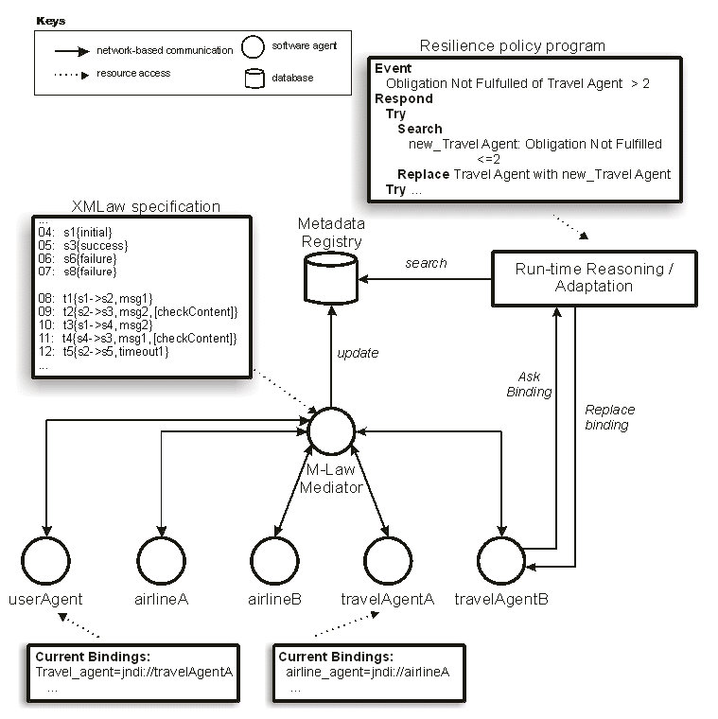
Figure 4: The Sample Scenario Architecture
The application architecture presents the M-Law mediator from the architecture style. The XMLaw specification includes the description of the scenario law (Table 3). The metadata registry includes the DepEx data in the format described in the next section. The runtime reasoning was instantiated with a resilience policy program. This program is application dependent and, in the sample scenario, it includes algorithms to check is some of the events are being fulfilled. Finally, the architecture is completed by the application agents.
The application agents exchange messages, which are intercepted by the M-Law mediator. The mediator reads the metadata registry to check if these messages conform to the DepEx requirements. Besides, can directly ask the runtime reasoning component to retrieve dependability metadata.
IV.4. The Sample Scenario Metadata Registry
The metadata registry, in this sample scenario, is composed of two entities: agent and dependability_data. The entity-relationship model is presented in Figure 5, and it is described in Table 7.
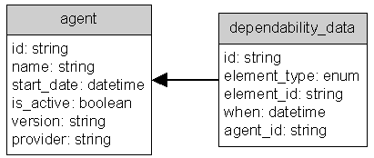
Figure 5: Entity-relationship Model of the Metadata Registry
Table 7: Attribute descriptions
agent | dependability_data
id – unique database identifier of the agent. | id – unique database identifier of the data.
name – the unique name of the agent | element_type – type of the XMLaw element. (eg: obligation, clock, …)
start_date – date when the agent was added to the registry | element_id – id if the XMLaw element
is_active – true if the agent is still running | when – date and time of the insertion of the metadata
version – version of the agent | agent_id – agent identification associated with this metadata
provider – organization that is in charge of the agent

The actions updateClockMetadata, updateHoldSeatMetadata, updateHoldReservationMetadata (lines 42, 43 and 44) are responsible for updating the metadata registry. In fact, these actions update the dependability metadata of the agents at runtime. Figure 6 and Figure 7 show screenshots of the registry database. For example, Figure 7 shows that the airlineA (agent_id=1) has not fulfilled the obligations hold-seat at February 1st and hold-reservation at February 3rd.
It is important to notice that these actions are very simple elements that obtain the contextual information at runtime and update the metadata registry. However, it is the law specification that tells when the actions should execute. In other words, the acquisition of the dependability metadata is done through the combined use of various XMLaw elements. It can clearly be seen in Table 4, where a transition, a clock, a norm and an action were connected to update the metadata.
Figure 6: Sample Scenario Agent Examples
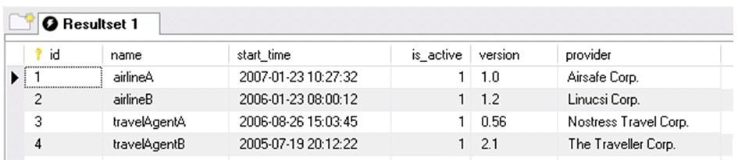
Figure 7: Sample Scenario Dependability Data Examples
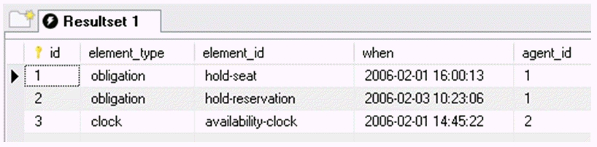
V. RELATED WORK
In [4], a position paper is presented that illustrates the use of OWL for dependability specifications. An advantage claimed by the author is that the ontology includes the definition of a controlled vocabulary. With the potential of confusion between parties, and domains about the meaning of dependability metrics, an ontology is therefore valuable for disambiguation.
In [2], a tool was presented for monitoring the dependability and performance of Web Services. The metadata acquisition and maintenance occurs from a specific location of a client (reflects problems with routers and service WSs). The results are collected and updated in an openly accessible DB. The tool measures the dependability of Web Services by acting as a client to the Web Service under investigation. The tool monitors a given Web Service by tracking the following reliability characteristics: (i) availability: the tool periodically makes dummy calls to the Web Service to check whether it is running; (ii) functionality: the tool makes calls to the Web Service and checks the returned results to ensure the Web Service is functioning properly; (iii) performance: the tool monitors the round-trip time of a call to the Web Services producing and displaying real time statistics on service performance; (iv) and faults and exceptions: the tool logs faults and exceptions during the test period of the Web Service for further analysis. Although the tool can be useful for many existent applications, when compared to the solution presented in this paper, the laws allow for a much more expressive and flexible way to collect domain-specific situations. For example, in the tool it is not possible to express any of the obligations stated in our case study.
Furthermore, to the best of our knowledge there is no solution that encompasses the various features presented in this paper: (i) enforcement of the interaction behavior; (ii) flexible and declarative behavior of the interactions; (iii) explicit incorporation of dependability concerns into the specification; (iv) and openly accessible database about dependability metadata (metadata registry).
VI. CONCLUSIONS
Our society is becoming increasingly dependent on complex software systems. This dependence in turn makes the task of building dependable systems a critical part of software development. Dependability explicit computing states that there is a need for integrating the dependability concerns at the very early stages of the development process. In this approach the dependability metadata should be specified as first-class entities that are available to guide decisions both at the design time and at run-time.
On the other hand, the law-governed approaches have already proposed various high level elements that allow for a flexible specification of the overall system behavior. Furthermore, they provide mediators that ensure that the behavior is being followed as expected. Law-governed approaches also promote dependability in the sense that the system becomes more predictable and some system failures can be prevented by the intervention of the mediator.
This paper has shown that DepEx and Law approaches are complementary. The laws can provide a powerful way to monitor and specify complex dependability metadata. To be more specific, we have incorporated the dependability explicit computing into the XMLaw approach. A detailed case study was presented with the goal of illustrating the acquisition of the metadata. The case study presented has three main contributions: (i) first it shows the integration of a law mechanism (M-Law) into the architecture that allows for dynamically resilient systems based on a metadata approach; (ii) second it shows that the laws can be a very powerful way not only to acquire dependability metadata, but also to interfere in the system execution when necessary (iii) Finally, with the laws, the dependability concerns are explicitly considered and precisely specified mostly in a declarative way. We have also shown the model of a metadata registry and how this model can be queried to return dependability metadata.
The approach presented in this paper has the advantage of flexibility and reuse. Flexibility, because in contrast to the related work, the high level abstractions presented in XMLaw allow for a very expressive and domain dependent way to acquire the metadata, while still preserving the declarative nature of the laws. And reuse, because we do not have to rebuild a new language nor a new mediator to perform the metadata acquisition. Therefore, XMLaw was shown to be flexible enough to incorporate various dependability concerns.
ACKNOWLEDGEMENTS
This work is partially supported by CNPq/Brazil under the project ESSMA (5520681/2002-0) and by individual grants from CNPq/Brazil.

REFERENCES
1. A. Avizienis, J-C. Laprie, B. Randell, and C. Landwehr. Basic concepts and taxonomy of dependable and secure computing. IEEE Transactions on Dependable and Secure Computing, 1(1): 11-33, 2004.
2. Y. Chen, P. Li, and A. Romanovsky. Web services dependability and performance monitoring. In Proceedings of the 21st UK Performance Engineering Workshop, 2005.
3. V. Dignum, J. Vazquez-Salceda, and F. Dignum. A model of almost everything: norms, structure and ontologies in agent organizations. In Proceedings of the AAMAS, p. 1498-1499, 2004.
4. G. Dobson. OWL and OWL-S for dependability-explicit service-centric computing. In Proceedings of the Service-Oriented Computing: Consequences for Engineering, p. 4-4, 2006
5. M. Esteva. Electronic institutions: from specification to development. Ph.D. thesis, Institut d'Investigación en Intelligência Artificial, Spain, 2003.
6. N. R. Jennings, K. Sycara, and M. Wooldridge. A roadmap of agent research and development. Autonomous Agents and Multi-Agent Systems, 1(1):7-38, 1998.
7. C. Jones, and B. Randell. Dependable pervasive systems. Technical Report CS-TR-839, School of Computing Science, University of Newcastle upon Tyne, 2004.
8. M. Kaâniche, J. Laprie, and J. Blanquart. A dependability-explicit model for the development of computing systems In Proceedings of the 19th International Conference on Computer Safety, Reliability and Security (LNCS 1943), p. 107-116, 2000.
9. N. Minsky, and V. Ungureanu. Law-governed interaction: a coordination and control mechanism for heterogeneous distributed systems. ACM Transactions on Software Engineering and Methodology, 9 (3):273-305, 2000.
10. R. Paes, G. Carvalho, C. Lucena, P. Alencar, H. Almeida, and V. Silva. Specifying laws in open multi-agent systems. In Proceedings of the ANIREM Workshop at AAMAS, 2005.
11. R. Paes, M. Gatti, G. Carvalho, L. Rodrigues, C. Lucena. A middleware for governance in open multi-agent systems. Technical Report MCC 33/06, PUC-Rio, 2006.
12. R. Paes, G. Carvalho, M. Gatti, C. Lucena, J-P. Briot, and R. Choren. Enhancing the environment with a law-governed service for monitoring and enforcing behavior in open multi-agent systems. In Environments for Multi-Agent Systems (LNCS 4389), p. 221-238, 2007.
13. G. Serugendo, J. Fitzgerald, A. Romanovsky, and N. Guelfi. Dependable self-organising software architectures – an approach for self-managing systems. Technical Report BBKCS-06-05, School of Computer Science and Information Systems, Birkbeck College, 2006.
14. X. Yi, and K. Kochut. Process composition of web services with complex conversation protocols: a colored petri nets based approach. In Proceedings of the Design, Analysis and Simulation of Distributed Systems Conference, p. 141-148, 2004.

